How to run backend:
- Go to project/banking-gui/server
- Right click the folder and select open in terminal
- Run this command “ npm install dotenv”
- In the server folder create a .env file
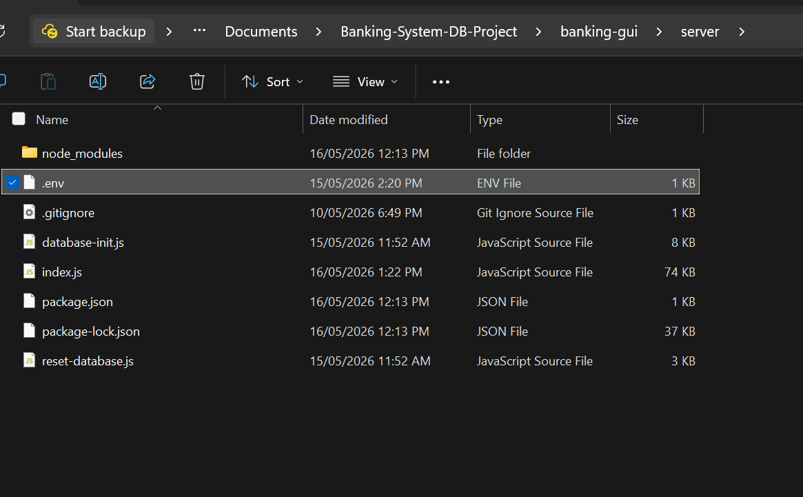
- Inside it write:
DB_USER=system
DB_PASSWORD=admin (or your database password)
DB_CONNECTION_STRING=localhost/XEPDB1
- Back in the terminal write “node index.js”
- You should see this:
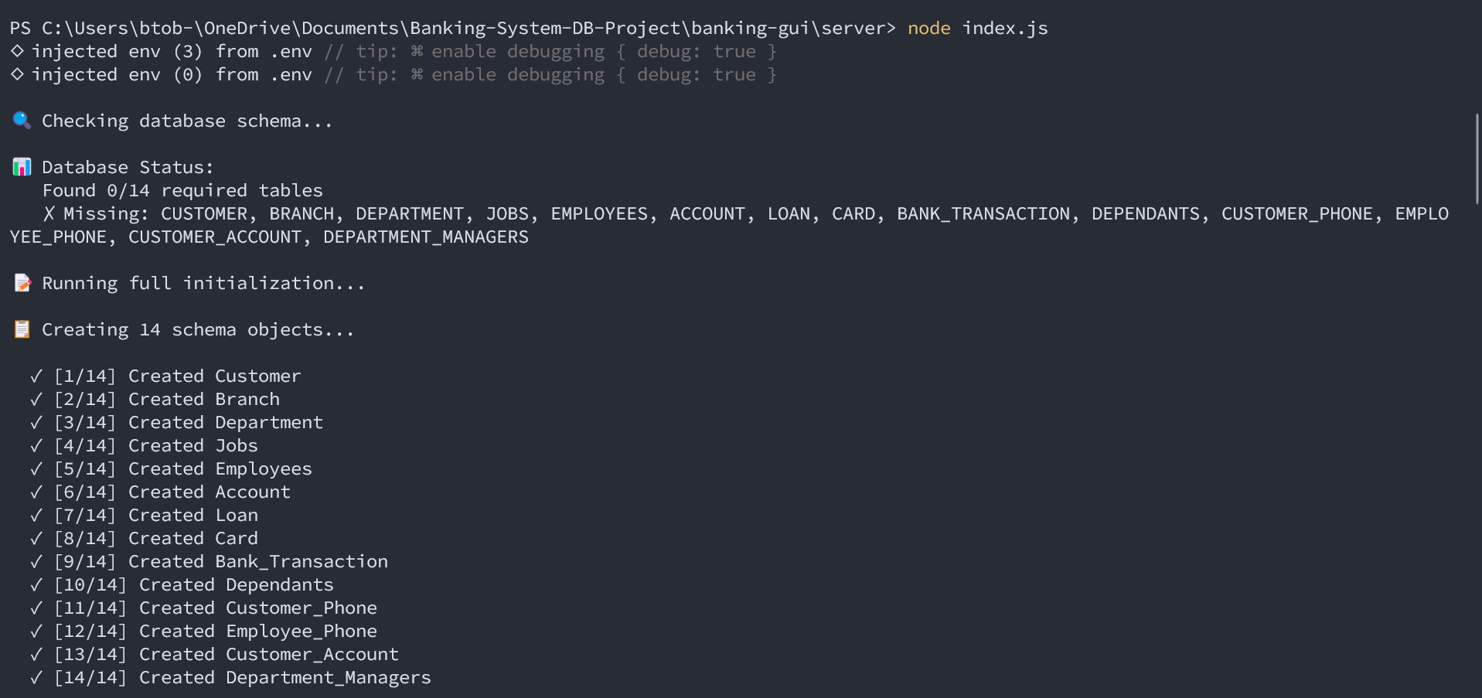
To run front-end:
- Open project/banking-gui/client
- Right click and open terminal
- Write the following commands:
“npm install”
“npm run dev”
- If you get this error:
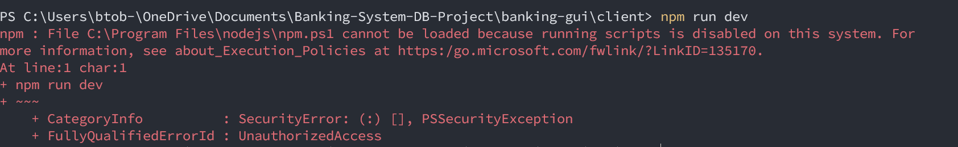write this command “Set-ExecutionPolicy -ExecutionPolicy Bypass -Scope Process”, then write “npm run dev”
- You should see this:
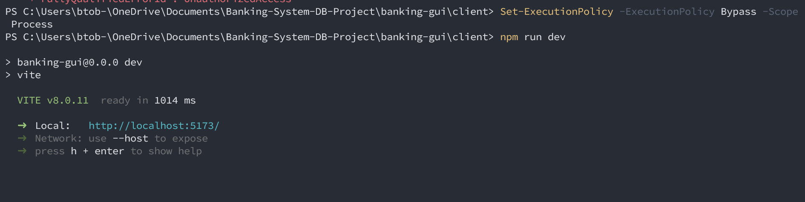
Open the website and the app is ready!

